Website Plan

My website aims to explore “The Impact of Pixelated Graphic Design in Gaming Culture”.

I’ll start by showing some research on why we had these graphics in the past and the potential for nostalgia nowadays by showing the same graphic quality.

Then I’ll look at some evidence of rise of popularity of this graphic design in games of the 10s of the 2nd millennium and why they are rising.

Sources (Research Sites)

**quora.com**

**en.wikipedia.org**

**www.raywenderlich.com/14865/introduction-to-pixel-art-for-games**

**https://www.theverge.com/2014/7/3/5865849/pixel-art-is-here-to-stay**

**https://www.statista.com**

Structure

Home Page

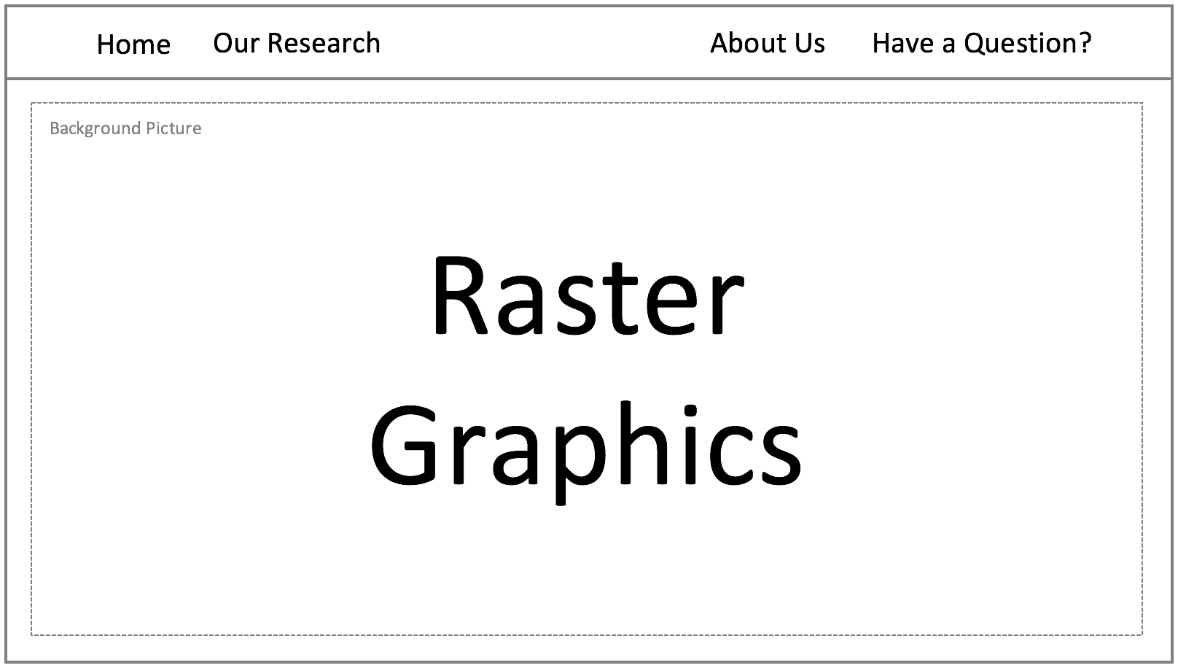

Other Pages

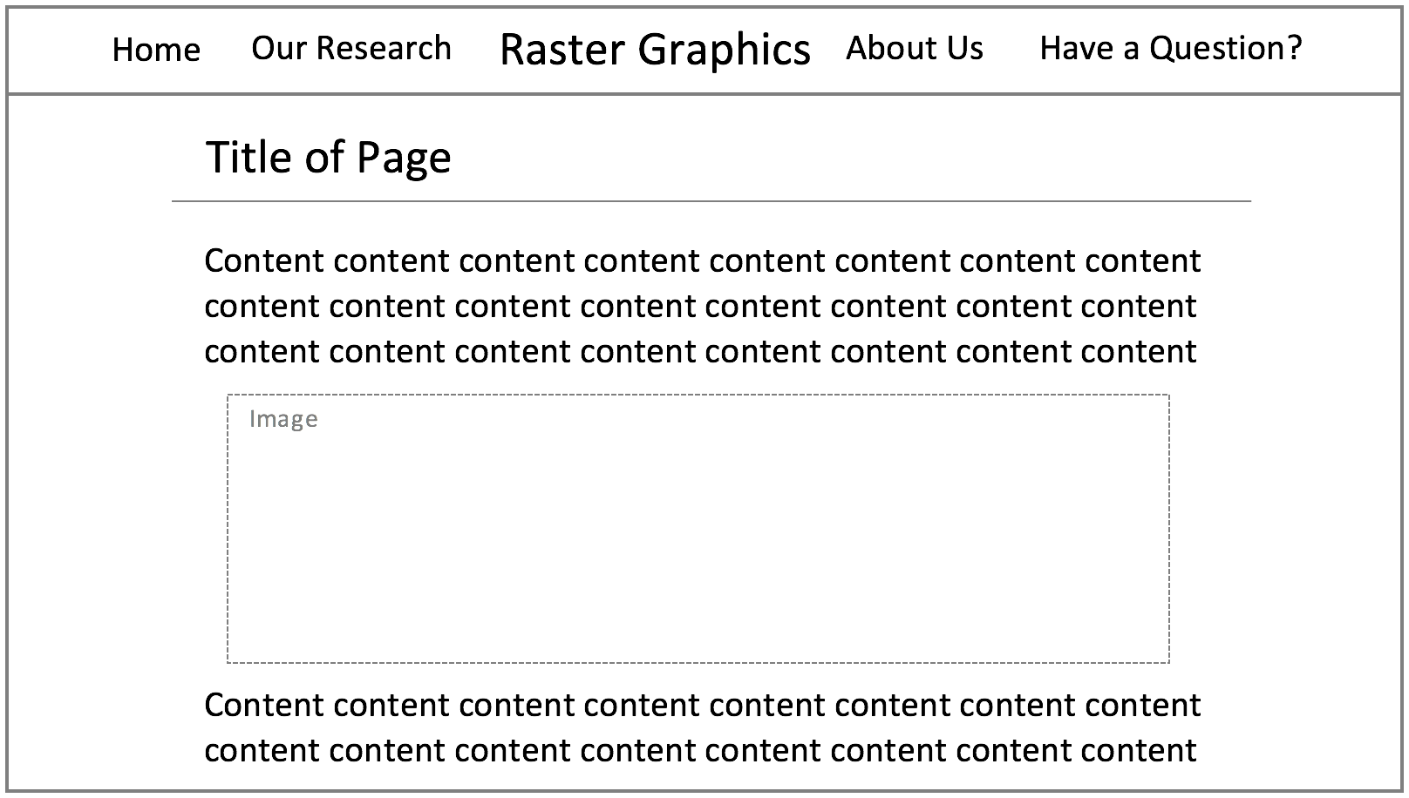

Website Navigation

